6. The online cake ordering system allows users to browse a variety of cakes by category, flavor, and occasion, complete with detailed descriptions and images. Users can register, log in, and manage their orders through a personal dashboard. The ordering process includes selecting a cake, customizing options like size and message, entering delivery details, and making secure payments via an integrated payment gateway. Admins can manage cake inventory, track orders, and handle user accounts through an admin panel. Users receive order confirmation emails and can track delivery status. The website is fully responsive, providing a seamless shopping experience on all devices. Buy a Cake is a portal which allows admin in developing counters to advertise and sell their cake. This would permit rural communities to make their wares available to the rest of the world. The proposed system is to develop the website for cake store. User can buy the nearby cake available in app. An E Com App is a portal which allows admin in developing products to promote and sell their goods. This would permit rural communities to make their wares available to the rest of the world.
AIM
To create a responsive Cake Ordering System webpage where users can browse cakes, customize an order, enter delivery details, and receive a sample order confirmation.
HTML CODE
<!DOCTYPE html>
<html lang="en">
<head>
<meta charset="UTF-8">
<meta name="viewport" content="width=device-width, initial-scale=1">
<title>Cake Ordering System</title>
<style>
body { font: 16px Arial, sans-serif; max-width: 700px; margin: 35px auto; padding: 20px; color: #222; }
.cake, form { border: 1px solid #ddd; border-radius: 8px; padding: 18px; margin: 15px 0; }
input, select, button { padding: 9px; margin: 5px 2px; }
button { cursor: pointer; }
</style>
</head>
<body>
<h1>Local Cake Store</h1>
<p>Browse and order cakes from nearby bakers.</p>
<div class="cake">
<h2>Chocolate Celebration Cake</h2>
<p>Rich chocolate cake, freshly prepared by a local baker.</p>
<p>Price: ₹800 · Available: 5</p>
</div>
<form id="orderForm">
<h2>Customize Your Order</h2>
<label>Cake
<select id="cake">
<option value="Chocolate Celebration Cake">Chocolate Celebration Cake — ₹800</option>
<option value="Vanilla Birthday Cake">Vanilla Birthday Cake — ₹700</option>
<option value="Fruit Cake">Fruit Cake — ₹900</option>
</select>
</label><br>

<label>Size
<select id="size">
<option>1 kg</option>
<option>2 kg</option>
<option>3 kg</option>
</select>
</label><br>
<input id="message" placeholder="Message on cake">
<input id="customer" placeholder="Your name" required>
<input id="address" placeholder="Delivery address" required>
<input id="phone" type="tel" placeholder="Phone number" required>
<p>Demo payment only — no real payment is collected.</p>
<button type="submit">Place Order</button>
</form>
<h2>Order Confirmation</h2>
<p id="result">Your order details will appear here.</p>
<script>
document.getElementById("orderForm").addEventListener("submit", function(event) {
event.preventDefault();
const cake = document.getElementById("cake").value;
const size = document.getElementById("size").value;
const message = document.getElementById("message").value || "No message";
const customer = document.getElementById("customer").value;
const address = document.getElementById("address").value;
const orderId = "CAKE" + Math.floor(10000 + Math.random() * 90000);
document.getElementById("result").textContent =
`Order ${orderId} confirmed for ${customer}: ${cake}, ${size}. ` +
`Cake message: "${message}". Delivery to: ${address}. Demo payment only.`;
});
</script>
</body>
</html>
OUTPUT
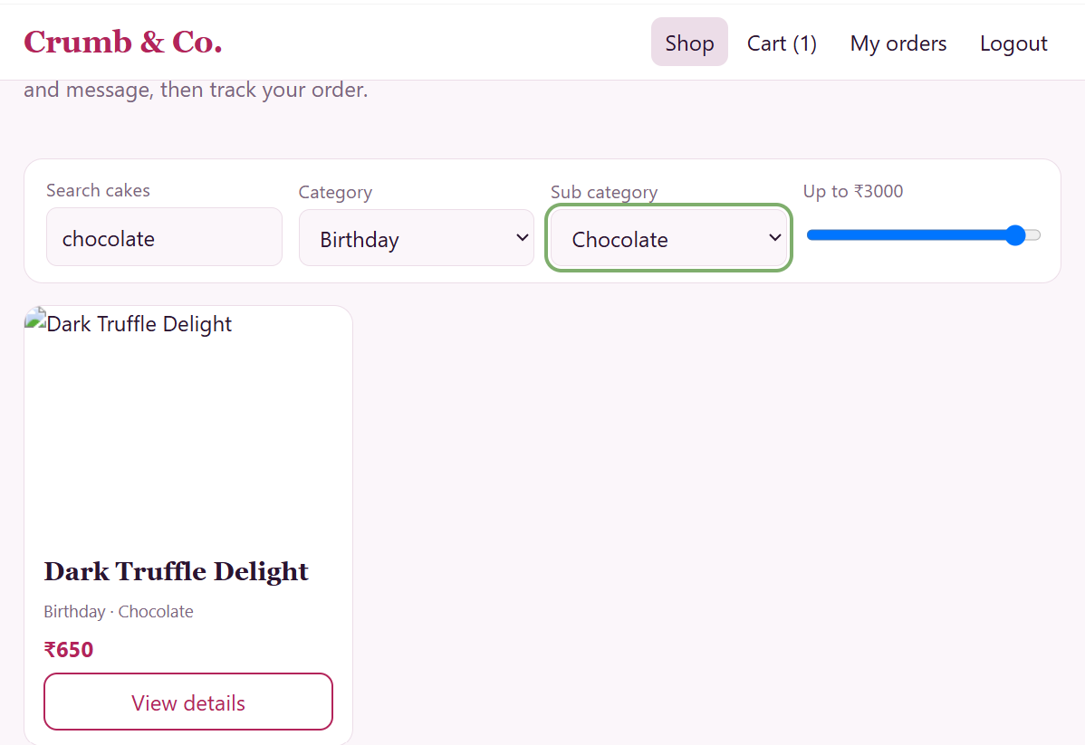
RESULT
The Cake Ordering System webpage was created successfully. Users can select a cake, choose its size, enter a cake message and delivery details, and receive a sample order confirmation.

